**자료구조론 CC343_2207**

**Programming assignment 2**

**경기대학교 컴퓨터공학부**

**201511837 이상민**

**Programming Examples**

**1.**

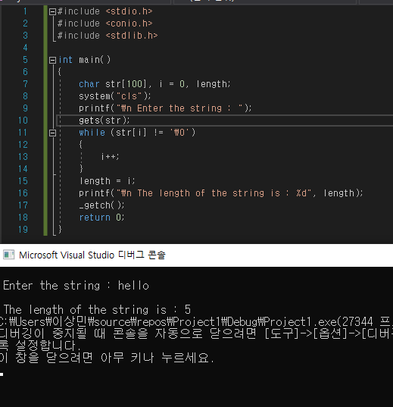

**2.** 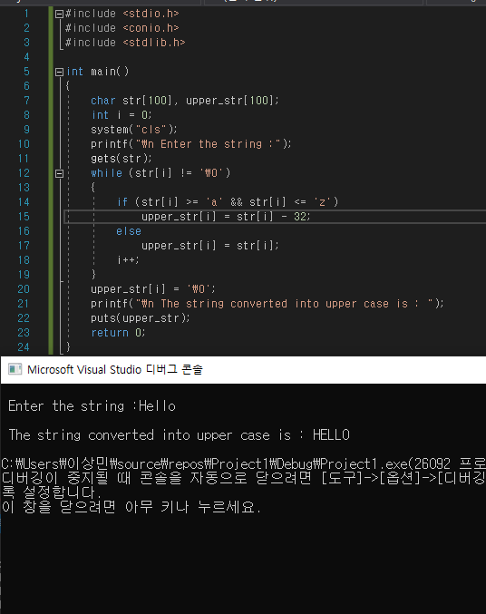

**3.**

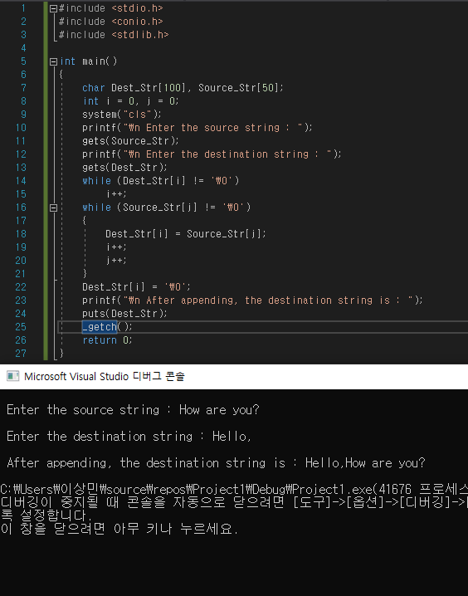

**4.**

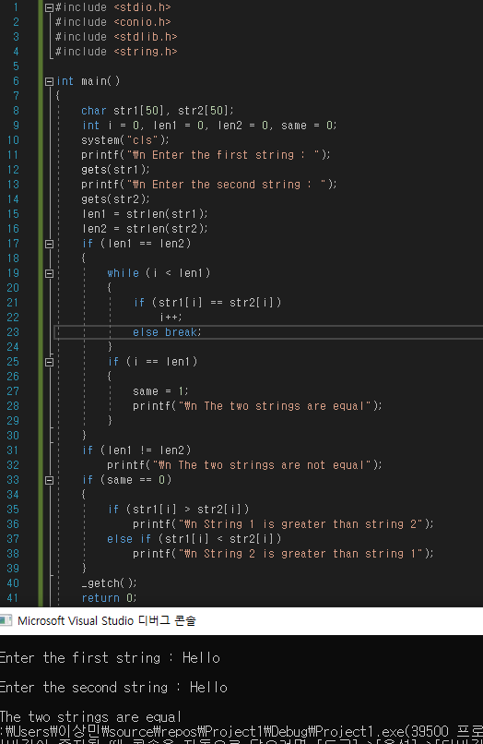

**5.**

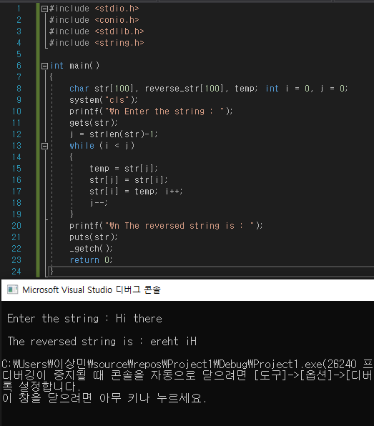

**6.**

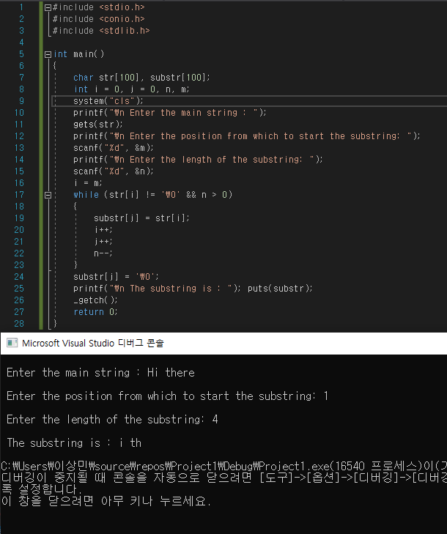

**7.**

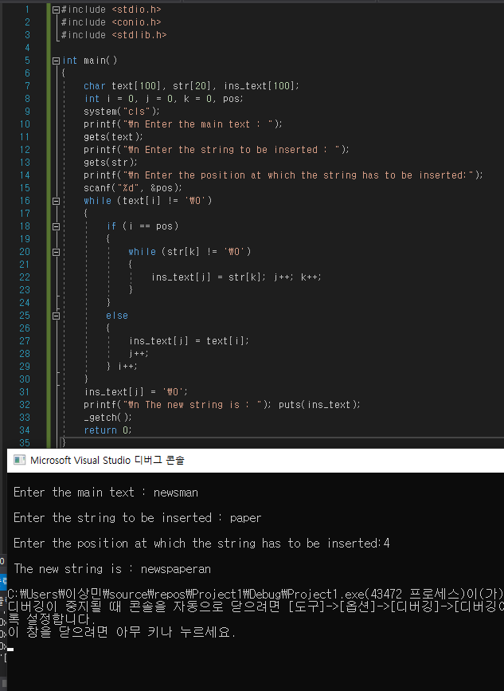

**8.**

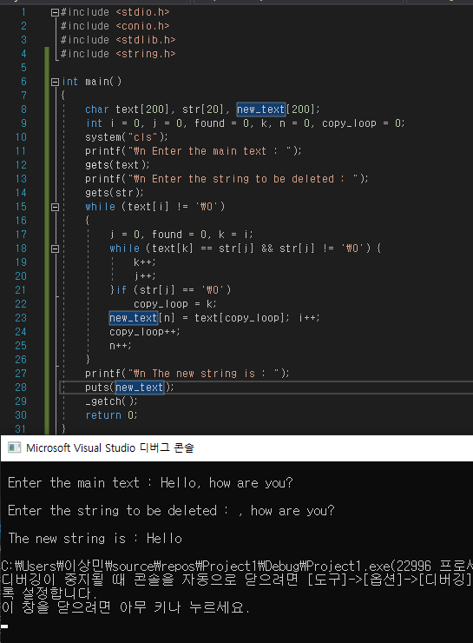

**9.**

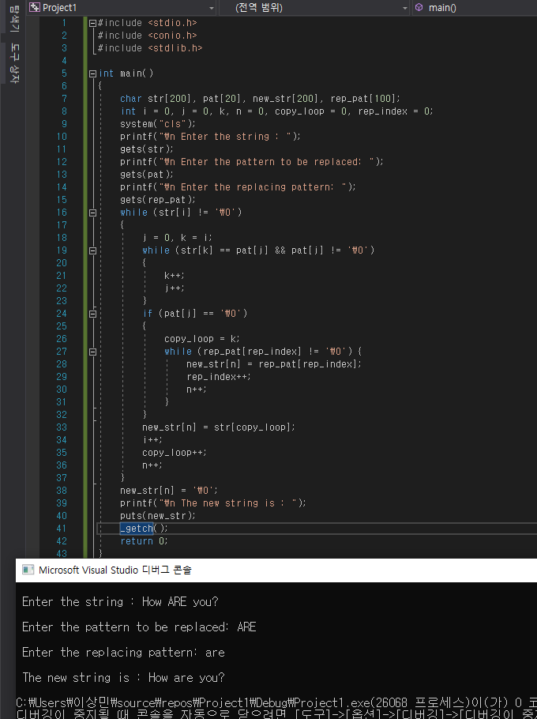

**10.**

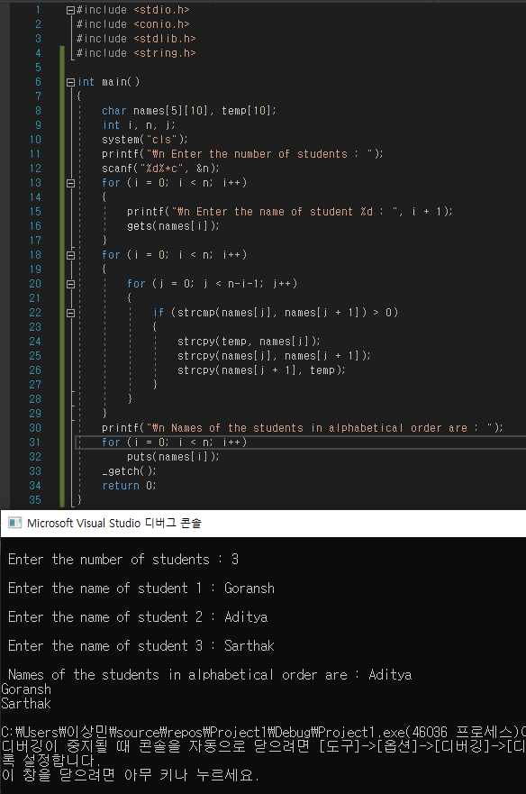

**#include <stdio.h>**

**#include <conio.h>**

**#include <stdlib.h>**

**#include <string.h>**

**int main()**

**{**

**char names[5][10], temp[10];**

**int i, n, j;**

**system("cls");**

**printf("\n Enter the number of students : ");**

**scanf("%d%*c", &n);**

**for (i = 0; i < n; i++)**

**{**

**printf("\n Enter the name of student %d : ", i + 1);**

**gets(names[i]);**

**}**

**for (i = 0; i < n; i++)**

**{**

**for (j = 0; j < n-i-1; j++)**

**{**

**if (strcmp(names[j], names[j + 1]) > 0)**

**{**

**strcpy(temp, names[j]);**

**strcpy(names[j], names[j + 1]);**

**strcpy(names[j + 1], temp);**

**}**

**}**

**}**

**printf("\n Names of the students in alphabetical order are : ");**

**for (i = 0; i < n; i++)**

**puts(names[i]);**

**_getch();**

**return 0;**

**}**

**11.**

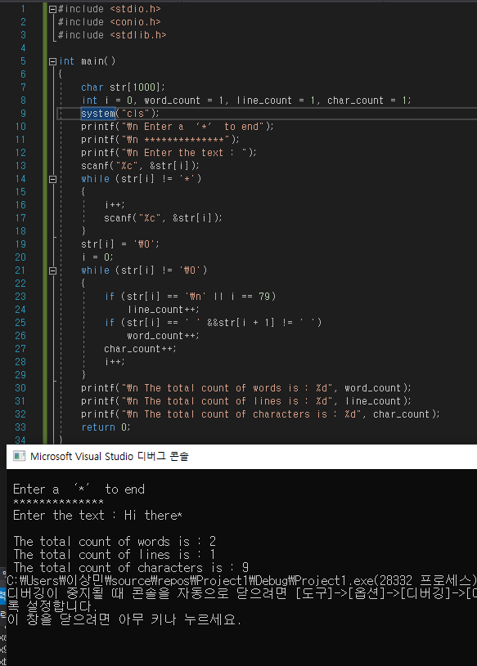

**12.**

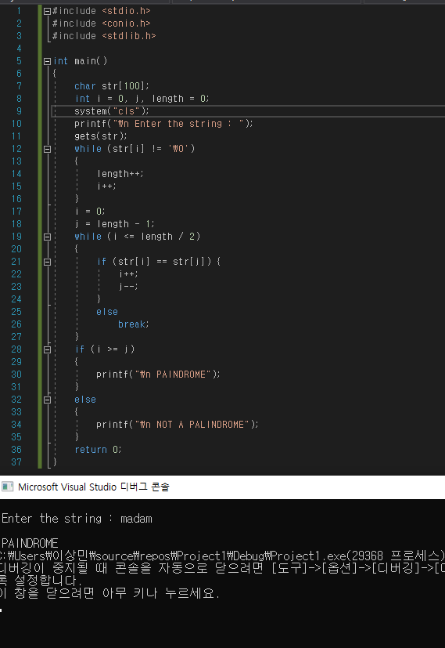

**13.**

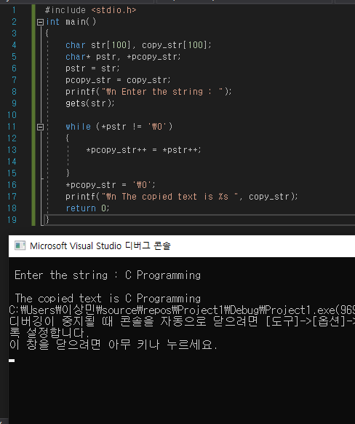

**14.**

